In the picture below, four whole numbers are being put into the box. Inside the box, a multiplication happens to each number, and then four new numbers are tipped out of the box: 56, 24, 112 and 216.
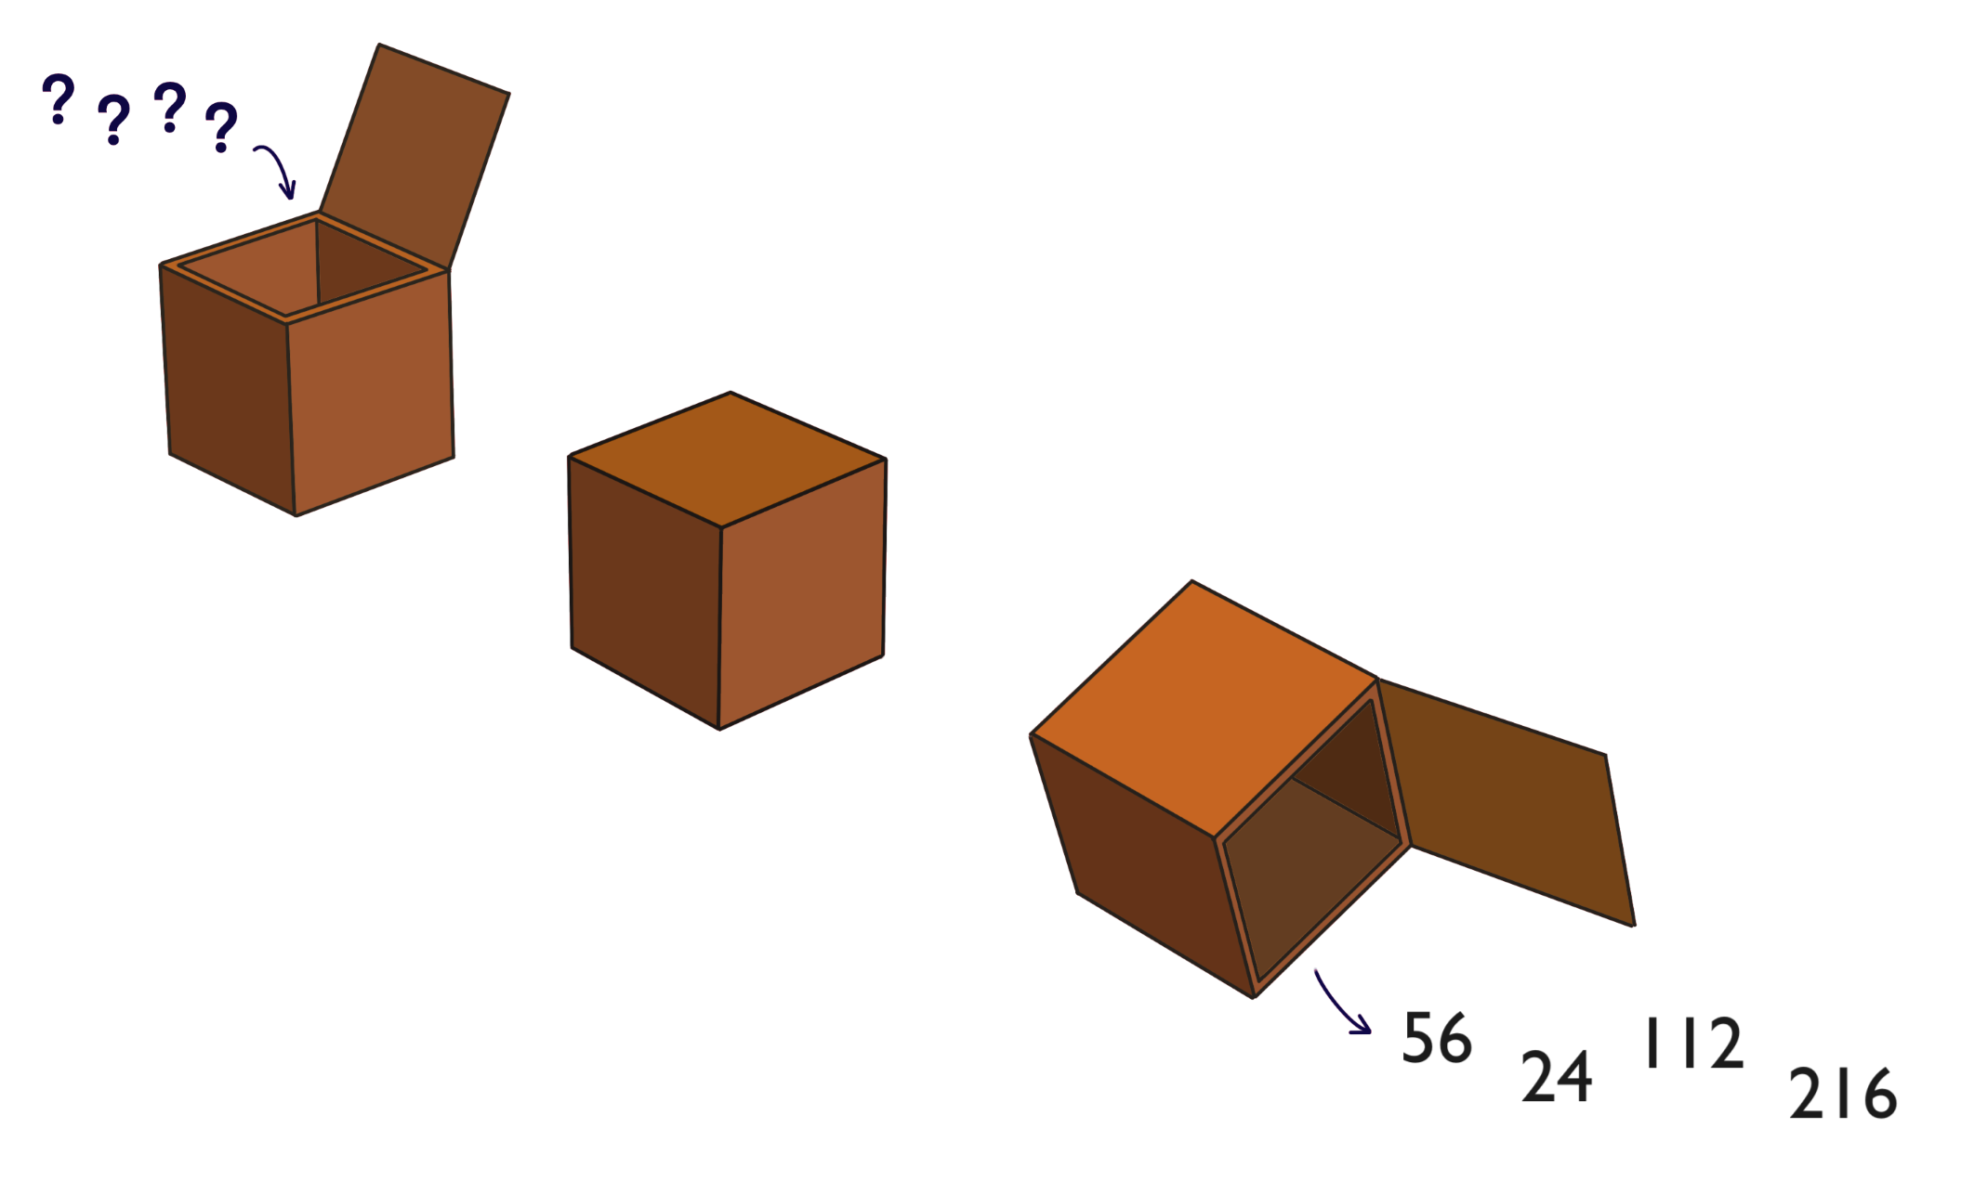
What multiplication might have happened to each number inside the box to get the answers in the picture above?
Are there any other possibilities?
What's the largest number that each of the four starting numbers might have been multiplied by inside the box? How do you know?
-----------
Imagine that four more numbers are put into the box, but now the box multiplies all of them by a new number. The numbers that come out of the box are:
143
297
341
1221
What number might the box be multiplying by? How do you know?
Discuss this with some other people and see if there are any different ways to work this out.

